**Tree influence exacerbates the El Niño effects over soil CO2 emissions and its microclimatic controls**

Pablo Salazar Zarzosa1, Elva Palacios Mc Cubbin1, Jorge Curiel Yuste2,3, Jannes Muenchow4, Gastón Cruz1 & Rodolfo Rodriguez1

*1 Facultad de ingenieria, Universidad de Piura. Av. Ramón Mujica 131, Piura, Perú*

2 BC3 - Basque Centre for Climate Change, Scientific Campus of the University of the Basque Country, 48940 Leioa, Spain

3 IKERBASQUE - Basque Foundation for Science, Maria Diaz de Haro 3, 6 solairua, 48013 Bilbao, Bizkaia, Spain

*4 Institute of Geography, Friedrich-Schiller University Jena, Löbdergraben 32, 07743 Jena, Germany*

Corresponding author: Pablo Salazar

e-mail: pcsalazarz@gmail.com

Phone: +51 942 111 077

**Key-words:** drought; EN; fertility island; temperature; Peru; canopy cover

# Abstract

Dryland ecosystems are considered the largest global carbon sink. However, extreme climate phenomena like the El Niño events (EN) may change soil respiration (Rs) – the CO2 emitted from soils resulting from biological activity and the largest outgoing flux of carbon from terrestrial ecosystems. Our aim was to study the effect of the EN on Rs in the North Peruvian dryland forest, and its interaction with soil temperature and the tree canopy. Our results indicate that Rs during the EN years increased by a factor of 100 compared to normal years, but this effect was exacerbated by the proximity to trees. Only under trees and during the EN event temperature exerted a positive control over daily Rs fluctuations. Our results, indicate how in these dryland forests the expected increase in the EN frequency and intensity could affect soil CO2 emissions, and hence ecosystem carbon budgets, but that this effect would very much depend on tree density and tree spatial distribution.

It has been estimated that soil respiration (Rs), the biogenic CO2 flux from the soil to the atmosphere, is 75 x 1015 gC/yr, which is roughly similar to the contribution of net primary production (NPP) (60 x 1015 gC/yr) (Schlesinger and Andrews, 2000). Therefore, small relative changes in Rs might be associated with large changes in absolute emissions of CO2 from long-term C pools (soil) to the atmosphere (Schlesinger and Andrews, 2000). Drylands are considered sinks for CO2 because the lack of precipitation reduce litter decomposition and microorganism activity (Nolan et al., 2018; Robertson et al., 2018). However, sudden changes in precipitation regimes may exacerbate soil CO2 emissions during hot moments (Vargas et al., 2018), with the potential to accelerate the soil C cycle and turn arid systems from sinks into sources.

In the North Peruvian dryland ecosystems, the high average annual temperature (23-24 °C) and low annual rainfall (50-150mm) are heavily interrupted every 5-7 years by El Niño events (EN). The increase in precipitation might be 15 times higher compared to the annual mean in north Peruvian drylands. This also increases the dry forest’s NPP manifold (Salazar et al., 2018). In this ecosystem, *Prosopis pallida* (Willd.) Kunth, hereafter referred to as Algarrobo, represents 67% of the total plant cover, and produce a “fertility island effect” that promotes litter decomposition, mineralization and the increase of soil nutrients under its canopy (Salazar et al., 2019). Decomposition of litter by the soil microbial communities results in increasing concentrations of mineral forms of key nutrients in soil (e.g., through nitrogen mineralization) and emissions of CO2 from their aerobic respiration, which explains the positive relationship between nitrogen (N) and carbon (C) cycles (Manzoni et al., 2006). In this particular arid systems where water availability limits vegetation cover, physical controls of soil biochemical cycles dominate over biological controls, resulting in stoichiometric imbalances that favors soil phosphorus (P) over soil C and N(Delgado-Baquerizo et al., 2013). Nevertheless, the increase in water availability during the EN should have a positive effect on soil microorganism activity and on the emissions of CO2 flux to the environment from their increase in biological activity (Aguilera et al., 2016). An increased occurrence of the EN has been forecasted, which may change the soil C cycle and plant-soil relationship in the near future (Cai et al., 2015). In the long term, this could transform dryland ecosystems from sinks into sources with global repercussions (Melillo et al., 2017).

We took the costal EN of 2017 as an opportunity to measure Rs, the result of the aerobic activity from autotrophic (roots and rhizosphere microorganisms) and heterotrophic (primarily soil microbial communities) soil compartments, and its interaction with the tree canopy. During this period, precipitation reached 778 mm which corresponds to a tenfold increase compared to the long-term average. The ecological impact on NPP was comparable to previous EN events (Wang et al., 2017). Our objective was to study the effect of the EN on Rs under and outside the Algarrobo canopy. Specifically, we were interested in answering the following questions: Is the coastal EN significantly modifying Rs? And how does Rs change due to the influence of Algarrobo tree cover and temperature? We hypothesized that the changes in moisture resulting from the effect of the coastal EN significantly increase Rs and the sensitivity of Rs to temperature, and these effects are intensified by the presence of tree and tree cover size.

The field work was carried out during a 24-hours cycle at the end of summer (April) and winter (August) in two consecutive years. The first sampling coincided with the Coastal EN (2017). The second sampling was carried out under ENSO neutral, i.e. dry conditions in the study area (2018). At the study site, we selected 20 Algarrobo trees randomly. One permanent plastic quadrant was placed at 2 meters from each tree base, under the tree canopy. To measure Rs outside the canopy influence, we additionally marked ten randomly selected points which had to be located more than 10 meters away from any tree or understory plant.

The Rs measurements were taken at the center of each plastic quadrant, 5 times a day (5:00, 9:00, 13:00, 16:00 and 21:00 h). The Rs and soil temperature measurements were made on the top soil without any understory plant in it using a CI-340 Handheld Photosynthesis System connected to a cylinder chamber of 73.5cm2 and 0.58L, with an air flow rate programmed at 0.5L/s. Figures and Pearson correlation analyses were carried out with the open source software R 3.5.0 to analyze the effect of temperature and canopy area on RS (R Core Team, 2019).

The coastal EN increased NPP as can be seen from the NDVI satellite image from the MODIS database (Fig. 1). Likewise, Rs was significantly higher during the EN (Fig 2A), and then became lower again over time (Fig. 2B). The same effects might be also observed in other areas equally affected by EN, e.g., the entire South American coast, Australia, Southern India and West Africa (Poulter et al., 2014). In these ecosystems, heterotrophs are adapted to water limitations and respond quickly to sudden rain pulses, when they meet their optimal conditions to decompose soil organic matter and increase the net CO2 emissions (López-Ballesteros et al., 2015). In 2018, a year after the EN, Rs was as low as the error range of the measurement device. Thus, Rs was either extremely low or virtually zero, and CO2 was not emitted.

The observed differences in Rs between years and between degree of tree influence (Figure 2a and 2b) suggest that tree proximity exacerbated the positive effect of EN over soil biological activityresulting inan EN-induced increase in Rs emissions of more than two folds under trees with respect to open areas. Independent of the year and condition, the high temperatures experienced by the studied ecosystem during winter and summer may explain the overall low Rs with respect to the mean global Rs when compare to the mean annual temperature (Fig. 2C and D) (Bond-Lamberty and Thomson, 2010). This is because at high temperatures enzyme efficiency of soil microorganisms decreases once they overpass their optimal temperature (Ye et al., 2019). It is well known that vegetation, and trees in particular, exert a strong positive control over soil biological activity, which has been particularly observed in the generally positive effect of tree proximity on RS (Högberg et al., 2001; Tang et al., 2005). This influence of trees over soil metabolic activity is multidimensional: e.g. autotrophic activity (roots and associated microbes) is maximal under trees, trees litter production increases soil organic matter content, soil microbial decomposition and nutrient mineralization. Moreover, tree canopy provides a nursery effect for soil microbiota, resulting in bigger microbial biomass (Bashan et al., 2012). Trees may also actively stimulate microbial decomposition (priming) through exudates production (Kuzyakov et al., 2000). Hence, when water is not limiting in this arid ecosystems (EN years) trees maximize the potential effect of climate over soil metabolic activity and hence soil CO2 emissions.

Besides rates, canopy cover also transforms controls of Rs, especially during EN years (Figure 3). In this regard, we here show that the relationship between diel variations in soil temperature, canopy cover and soil moisture seem to shape patterns of Rs-derived CO2 emissions under trees, while no effects of temperature or moisture over Rs could be detected outside the canopy. Canopy tree size, soil temperature and soil moisture had a positive effect on Rs under the tree canopy during the EN, (Fig. 3A, B and C). Tree size has a positive effect on soil carbon and nutrients because size is generally correlated with leaf litter production (Geesing et al., 2000; Salazar et al., 2019) whereas it is well known that both, autotrophic and heterotrophic activities are generally positively influenced by temperature and moisture (Curiel Yuste et al., 2007). A year after the EN, when soil moisture decreased to very low values, only a slight (but significant) negative effect of soil temperature over Rs persisted under tree canopy (Fig. 3D, E and F).

In conclusion, the EN is an environmental force able to shape soil C in arid ecosystems, but the effect may strongly depend on the distribution and size of the trees. Changing climate conditions will have different effects on biogeochemical reactions controlling key ecosystem functions and services in drylands, from local to global scales.

# Acknowledgments

Financial support was provided by the Peruvian program CONCYTEC (163-2018-FONDECYT-BM-IADT-SE) granted to Dr. Pablo Salazar. Jorge Curiel Yuste is indebted to the Basque Government through the BERC 2018-2021 program, and by the Spanish Ministry of Science, Innovation and Universities through the BC3 María de Maeztu excellence accreditation (MDM-2017-0714).

# References

Aguilera, L.E., Armas, C., Cea, A.P., Gutiérrez, J.R., Meserve, P.L., Kelt, D.A., 2016. Rainfall, microhabitat, and small mammals influence the abundance and distribution of soil microorganisms in a Chilean semi-arid shrubland. J. Arid Environ. 126, 37–46. https://doi.org/10.1016/j.jaridenv.2015.11.013

Bashan, Y., Salazar, B.G., Moreno, M., Lopez, B.R., Linderman, R.G., 2012. Restoration of eroded soil in the Sonoran Desert with native leguminous trees using plant growth-promoting microorganisms and limited amounts of compost and water. J. Environ. Manage. 102, 26–36. https://doi.org/10.1016/j.jenvman.2011.12.032

Bond-Lamberty, B., Thomson, A., 2010. Temperature-associated increases in the global soil respiration record. Nature 464, 579–582. https://doi.org/10.1038/nature08930

Cai, W., Santoso, A., Wang, G., Yeh, S.-W., An, S.-I., Cobb, K.M., Collins, M., Guilyardi, E., Jin, F.-F., Kug, J.-S., Lengaigne, M., McPhaden, M.J., Takahashi, K., Timmermann, A., Vecchi, G., Watanabe, M., Wu, L., 2015. ENSO and greenhouse warming. Nat. Clim. Chang. 5, 849–859. https://doi.org/10.1038/nclimate2743

Curiel Yuste, J., Baldocchi, D.D., Gershenson, A., Goldstein, A., Misson, L., Wong, S., 2007. Microbial soil respiration and its dependency on carbon inputs, soil temperature and moisture. Glob. Chang. Biol. 13, 2018–2035. https://doi.org/10.1111/j.1365-2486.2007.01415.x

Delgado-Baquerizo, M., Maestre, F.T., Gallardo, A., Bowker, M.A., Wallenstein, M.D., Quero, J.L., Ochoa, V., Gozalo, B., García-Gómez, M., Soliveres, S., García-Palacios, P., Berdugo, M., Valencia, E., Escolar, C., Arredondo, T., Barraza-Zepeda, C., Bran, D., Carreira, J.A., Chaieb, M., Conceicao, A.A., Derak, M., Eldridge, D.J., Escudero, A., Espinosa, C.I., Gaitán, J., Gatica, M.G., Gómez-González, S., Guzman, E., Gutiérrez, J.R., Florentino, A., Hepper, E., Hernández, R.M., Huber-Sannwald, E., Jankju, M., Liu, J., Mau, R.L., Miriti, M., Monerris, J., Naseri, K., Noumi, Z., Polo, V., Prina, A., Pucheta, E., Ramírez, E., Ramírez-Collantes, D.A., Romao, R., Tighe, M., Torres, D., Torres-Díaz, C., D. Ungar, E., Val, J., Wamiti, W., Wang, D., Zaady, E., 2013. Decoupling of soil nutrient cycles as a function of aridity in global drylands. Nature 502, 672–676. https://doi.org/10.1038/nature12670

Geesing, D., Felker, P., Bingham, R.L., 2000. Influence of mesquite (Prosopis glandulosa) on soil nitrogen and carbon development: Implications for global carbon sequestration. J. Arid Environ. 46, 157–180. https://doi.org/10.1006/jare.2000.0661

Högberg, P., Nordgren, A., Buchmann, N., Taylor, A.F.S., Ekblad, A., Högberg, M.N., Nyberg, G., Ottosson-Löfvenius, M., Read, D.J., 2001. Large-scale forest girdling shows that current photosynthesis drives soil respiration. Nature 411, 789–792. https://doi.org/10.1038/35081058

Kuzyakov, Y., Friedel, J.., Stahr, K., 2000. Review of mechanisms and quantification of priming effects. Soil Biol. Biochem. 32, 1485–1498. https://doi.org/10.1016/S0038-0717(00)00084-5

López-Ballesteros, A., Serrano-Ortiz, P., Sánchez-Cañete, E. vP., Oyonarte, C., Kowalski, A.S., Pérez‐Priego, Ó., Domingo, F., 2015. Rain pulses enhance the net CO2 release of a semi‐arid grassland in SE Spain. J. Geophys. Res. Biogeosciences doi:10.1002/2015JG003091. https://doi.org/10.1002/2015JG003091.Received

Manzoni, S., Porporato, A., D’odorico, P., 2006. Modeling of carbon and nitrogen cycling in arid and semiarid ecosystems, in: Dryland Ecohydrology. Kluwer Academic Publishers, Dordrecht, pp. 183–199. https://doi.org/10.1007/1-4020-4260-4_11

Melillo, J.M., Frey, S.D., DeAngelis, K.M., Werner, W.J., Bernard, M.J., Bowles, F.P., Pold, G., Knorr, M.A., Grandy, A.S., 2017. Long-term pattern and magnitude of soil carbon feedback to the climate system in a warming world. Science (80-. ). 358, 101–105. https://doi.org/10.1126/science.aan2874

Nolan, R.H., Sinclair, J., Eldridge, D.J., Ramp, D., 2018. Biophysical risks to carbon sequestration and storage in Australian drylands. J. Environ. Manage. 208, 102–111. https://doi.org/10.1016/j.jenvman.2017.12.002

Poulter, B., Frank, D., Ciais, P., Myneni, R.B., Andela, N., Bi, J., Broquet, G., Canadell, J.G., Chevallier, F., Liu, Y.Y., Running, S.W., Sitch, S., van der Werf, G.R., 2014. Contribution of semi-arid ecosystems to interannual variability of the global carbon cycle. Nature 509, 600–603. https://doi.org/10.1038/nature13376

Robertson, A.D., Zhang, Y., Sherrod, L.A., Rosenzweig, S.T., Ma, L., Ahuja, L., Schipanski, M.E., 2018. Climate Change Impacts on Yields and Soil Carbon in Row Crop Dryland Agriculture. J. Environ. Qual. 47, 684. https://doi.org/10.2134/jeq2017.08.0309

Salazar, P.C., Navarro-Cerrillo, R.M., Ancajima, E., Duque Lazo, J., Rodríguez, R., Ghezzi, I., Mabres, A., 2018. Effect of climate and ENSO events on Prosopis pallida forests along a climatic gradient. For. An Int. J. For. Res. 165–177. https://doi.org/10.1093/forestry/cpy014

Salazar, P.C., Navarro-Cerrillo, R.M., Grados, N., Cruz, G., Barrón, V., Villar, R., 2019. Tree size and leaf traits determine the fertility island effect in Prosopis pallida dryland forest in Northern Peru. Plant Soil 437, 117–135. https://doi.org/10.1007/s11104-019-03965-7

Schlesinger, W.H., Andrews, J.A., 2000. Soil Respiration and the Global Carbon Cycle. Biogeochemistry 48, 7–20. https://doi.org/10.1023/A

Tang, J., Baldocchi, D.D., Xu, L., 2005. Tree photosynthesis modulates soil respiration on a diurnal time scale. Glob. Chang. Biol. 11, 1298–1304. https://doi.org/10.1111/j.1365-2486.2005.00978.x

Vargas, R., Sánchez-Cañete P., E., Serrano-Ortiz, P., Curiel Yuste, J., Domingo, F., López-Ballesteros, A., Oyonarte, C., 2018. Hot-moments of soil CO2 efflux in a water-limited grassland. Soil Syst. 2, 47. https://doi.org/10.3390/soilsystems2030047

Wang, G., Cai, W., Gan, B., Wu, L., Santoso, A., Lin, X., Chen, Z., McPhaden, M.J., 2017. Continued increase of extreme El Niño frequency long after 1.5 °C warming stabilization. Nat. Clim. Chang. 1–6. https://doi.org/10.1038/nclimate3351

Ye, J., Bradford, M.A., Dacal, M., Maestre, F.T., García‐Palacios, P., 2019. Increasing microbial carbon use efficiency with warming predicts soil heterotrophic respiration globally. Glob. Chang. Biol. 25, 3354–3364. https://doi.org/10.1111/gcb.14738

# Figures

Fig. 1. Normalized difference vegetation index (MOD13A3) in the North Peruvian dryland forest (UTM) from the Terra Moderate Resolution Imaging Spectroradiometer (MODIS) database before the EN (December 2016 on the top) and after the EN (March 2017 on the bottom).

Fig. 2. Mean soil respiration rate in 2017 (A) and 2018 (B), at the end of summer (April) and winter (August) under (peach bars) and outside (green bars) the canopy cover of Algarrobo. Upper error bars indicate the standard error of the mean in each case. Two scatterplots of temperature and soil respiration in summer (C) and winter (D). Please note that the black dots represent the mean annual temperature and mean soil respiration rate taken from the global database (Bond-Lamberty and Thomson, 2010). By contrast, the blue and red dots represent the soil respiration and temperature as measured under the Algarrobo canopy in 2017 and 2018, respectively, i.e., these are not mean values.

Fig. 3. Pearson correlation analysis between soil respiration and tree canopy area, soil temperature, and soil humidity during 2017 (A, B, and C, respectively, in blue), and during 2018 (C, D, and E, respectively, in red) under the tree canopy.

Fig 1

C:\Users\FISICA\Dropbox\Respiracion de suelo\ASE\Fig1.tif

Fig 2

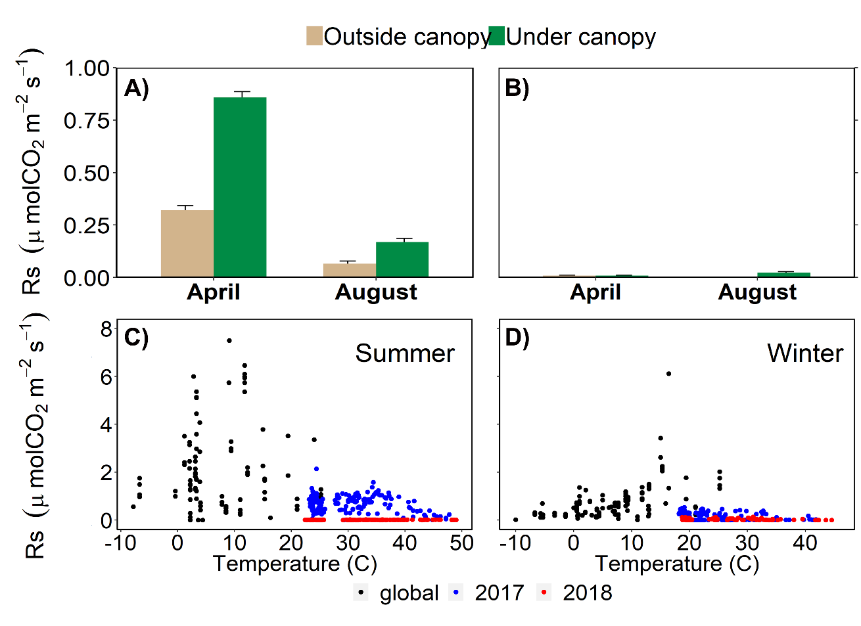

Fig. 3

C:\Users\Laboratorio\Dropbox\Respiracion de suelo\ASE\Fig3ASE.tif